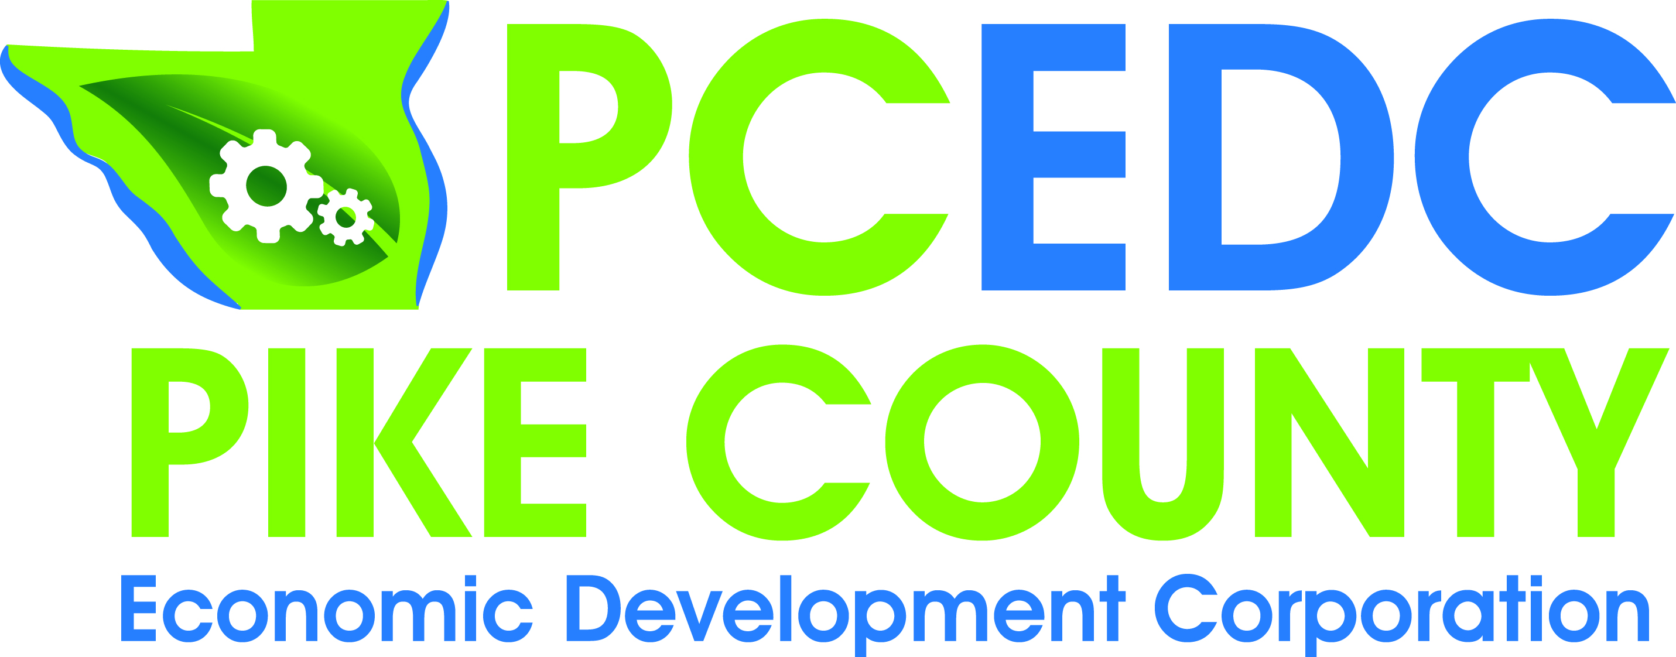
PCEDC Quarterly Membership Meeting
AGENDA
Monday, April 22, 2019
Farm Bureau Conference Room
Call to Order………………………………………………………………………………….…….………Conley
Minutes of February 25, 2019 Board Meeting…………………..……………………..….Spann
Financial Report……………………………………………………………….……………………..…Gengler
Marketing Report……………………………………………………………………………………Camarano
Director’s Report………………………………………………………………………………….Middendorf

Enter into Closed Session for Voting Members
Old Business..………………………………………………………………………Conley & Middendorf
- Annual Meeting Recap
- Small Business Workshop Update
- Tire Collection
- Household Hazardous Collection Update

New Business………………………………………………………………………………………. Middendorf
- Recycling Change
- Peace Corps Intern
- U S Census
- Job Fair

Chairman’s Comments………………………………………………………………………………..Conley
Visitor Comments………………………………………………………………………………………..Conley
Member Updates & Comments………………………………………..…………………………...…All

Exit closed session - Voting for Closed Session Items
Next Executive/Voting Meeting: ??? Falls on Memorial Day
Next Quarterly Meeting: June 24, 2019
Adjourn

