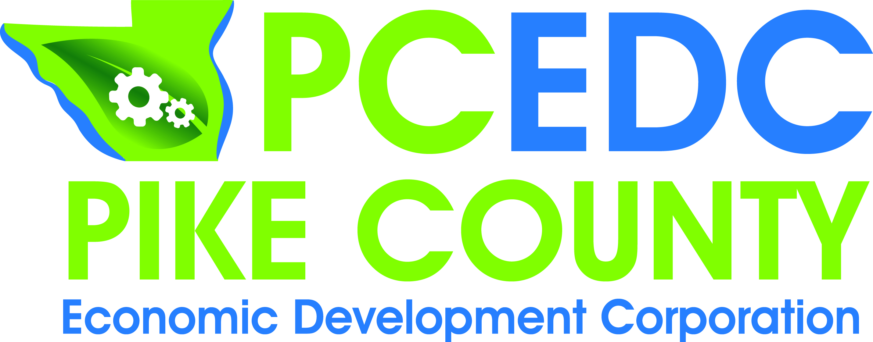
PCEDC Quarterly Membership Meeting
AGENDA
Monday, November 26, 2018
Farm Bureau Conference Room
Call to Order………………………………………………………………………………….…….………Conley
Minutes of October 22, 2018 Executive Board Meeting……………………………..….Spann
Financial Report……………………………………………………………….……………………..…Gengler
Marketing Report……………………………………………………………………………………Camarano
Director’s Report………………………………………………………………………………….Middendorf

Enter into Closed Session for Voting Members
Old Business..………………………………………………………………………Conley & Middendorf
- GPS Mapping
- Small Business Workshop Update
- Highway 54 Corridor Meeting
- MAPPING Update
- Recycling
- CEDS Meeting
- Film Office Update

New Business………………………………………………………………………………………. Middendorf
- Resume Workshops
- Sign

Chairman’s Comments………………………………………………………………………………..Conley
Visitor Comments………………………………………………………………………………………..Conley
Member Updates & Comments………………………………………..…………………………...…All

Exit closed session - Voting for Closed Session Items
Next Executive/Voting Meeting: Monday, January 28, 2019
Next Quarterly Meeting: December ??, 2018
Adjourn

