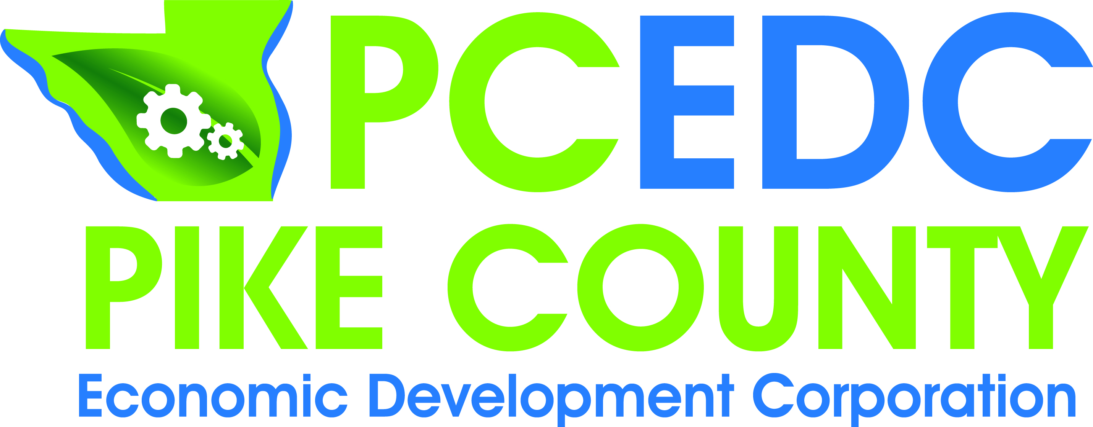
PCEDC Board Meeting
(This will be a Quarterly Meeting Format due to no December Meeting)
AGENDA
Monday, January 28, 2019
Farm Bureau Conference Room
Call to Order………………………………………………………………………………….…….………Conley
Minutes of September 24, 2018 Quarterly Meeting &
November 26, 2018 Executive Board Meeting……………………………….………..….Spann
Financial Report……………………………………………………………….……………………..…Gengler
Marketing Report……………………………………………………………………………………Camarano
Director’s Report………………………………………………………………………………….Middendorf

Old Business..………………………………………………………………………Conley & Middendorf
- Small Business Workshop Update
- Highway 54 Corridor Meeting
- MAPPING Update
- Recycling
- CEDS Meeting
- Resume Workshop Update
- Accommodation Tax Update

New Business………………………………………………………………………………………. Middendorf
- Vervacity Proposal
- 30th Annual Rural Development Conference
- Future Meeting Dates
- Annual Meeting
- Nominating Committee

Chairman’s Comments………………………………………………………………………………..Conley
Visitor Comments………………………………………………………………………………………..Conley
Member Updates & Comments………………………………………..…………………………...…All

Next Executive/Voting Meeting: February ??< 2019
Next Quarterly Meeting: Annual Meeting - March ??, 2019
Adjourn

