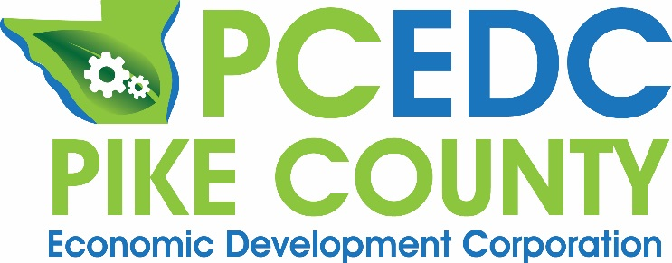
If you need additional help with QuickBooks, here is your chance for free training! Both beginner and advanced sessions are available. Harrison Business Services is partnering with PCEDC and JWCC to make these sessions available for you free of charge. Sessions will last 60 to 90 minutes with a question and answer session included. The Basic session will be offered Feb 6th from 6:00 pm to 7:30 pm and the Advanced Session will be offered the following night, Feb. 7th from 6:00 pm to 7:30 pm. Both sessions will be held at JWCC Southeast Education Center, 39637 260th Ave. | Pittsfield, IL. Sign up for one or both. Space is limited so register now at jkrohn@pikeedc.org

Description of QuickBooks classes:

February 6th: Basic:
Choose this QuickBooks class if you are new to QuickBooks or if you only need to use the basic features. Both QuickBooks Desktop and QuickBooks Online will be covered. Topics will include:
installation, setting up chart of accounts, setting up billable items, handling inventory
and sales tax, setting up customers, setting up vendors, using write checks vs enter
bills/pay bills, cash vs accrual financial statements, etc. A Q&A session will allow current
users to ask questions they have encountered.

February 7th: Advanced:
If you are already familiar with QuickBooks and need to learn to use some of the advanced features, then this is the right QuickBooks course for you. This session will go into greater depth of the above topics and will include exporting data to Excel and Word, creating reports, creating graphs, printing financial statements, cash & accrual basis.
About Your Instructors from Noble D. Harrison II, P.C.:

N.D. Harrison
Education: William Jewell College, University of Missouri-Columbia (Bachelor’s in
Accounting), University of Illinois–Urbana/Champaign (Master of Accounting Science)
Other: Certified Public Accountant, former QuickBooks Professional Advisor (Desktop
version), taxation of individuals, corporations, S corporations, partnerships and trusts.

Michael Jennings
Education: John Wood Community College (Associates Degree in Business), Southern
Illinois University at Edwardsville (Bachelor’s Degree in Accounting, Kaplan University
(Master’s degree in accounting with Tax Specialization)
Other: Current QuickBooks Online Professional Advisor, QuickBooks experience
includes farming, construction, restaurants, service and retail business, professionals.

